Notice of Public Hearing
to consider adoption of a new rural plan
Municipality of Grand Lake Rural Plan – By-Law No. 12
Pursuant to Section 111 of the Community Planning Act, public notice is hereby given that the Council of the Municipality of Grand Lake is considering the adoption of a new rural plan – the Municipality of Grand Lake Rural Plan – By-Law No.12:

A Public Hearing concerning the adoption of the new rural plan has been set for Monday, September 21st, 2026, at the Council meeting beginning at 7:00 p.m. at the Chipman Municipal Office, 10 Civic Court, Chipman, NB E4A 2H9.

Any person may obtain a copy of the proposed rural plan at the Municipality of Grand Lake Municipal Office, from 8:30 to 4:30 Monday to Friday; at the Capital Region Service Commission office, 1133 Regent Street, Suite 300, in Fredericton between the hours of 8:00 am and 4:00 pm, Monday to Friday; or at the Municipality of Grand Lake website: https://municipalityofgrandlake.ca/

Persons wishing to comment on the proposed rural plan may do so at the public hearing or in writing to Capital Region Service Commission, 1133 Regent Street, Suite 300, Fredericton, NB, E3B 3Z2 or by email to ruralplans@capitalrsc.ca. Written comments may be submitted to the above address until 4:00 pm on Monday, October 5th, 2026.

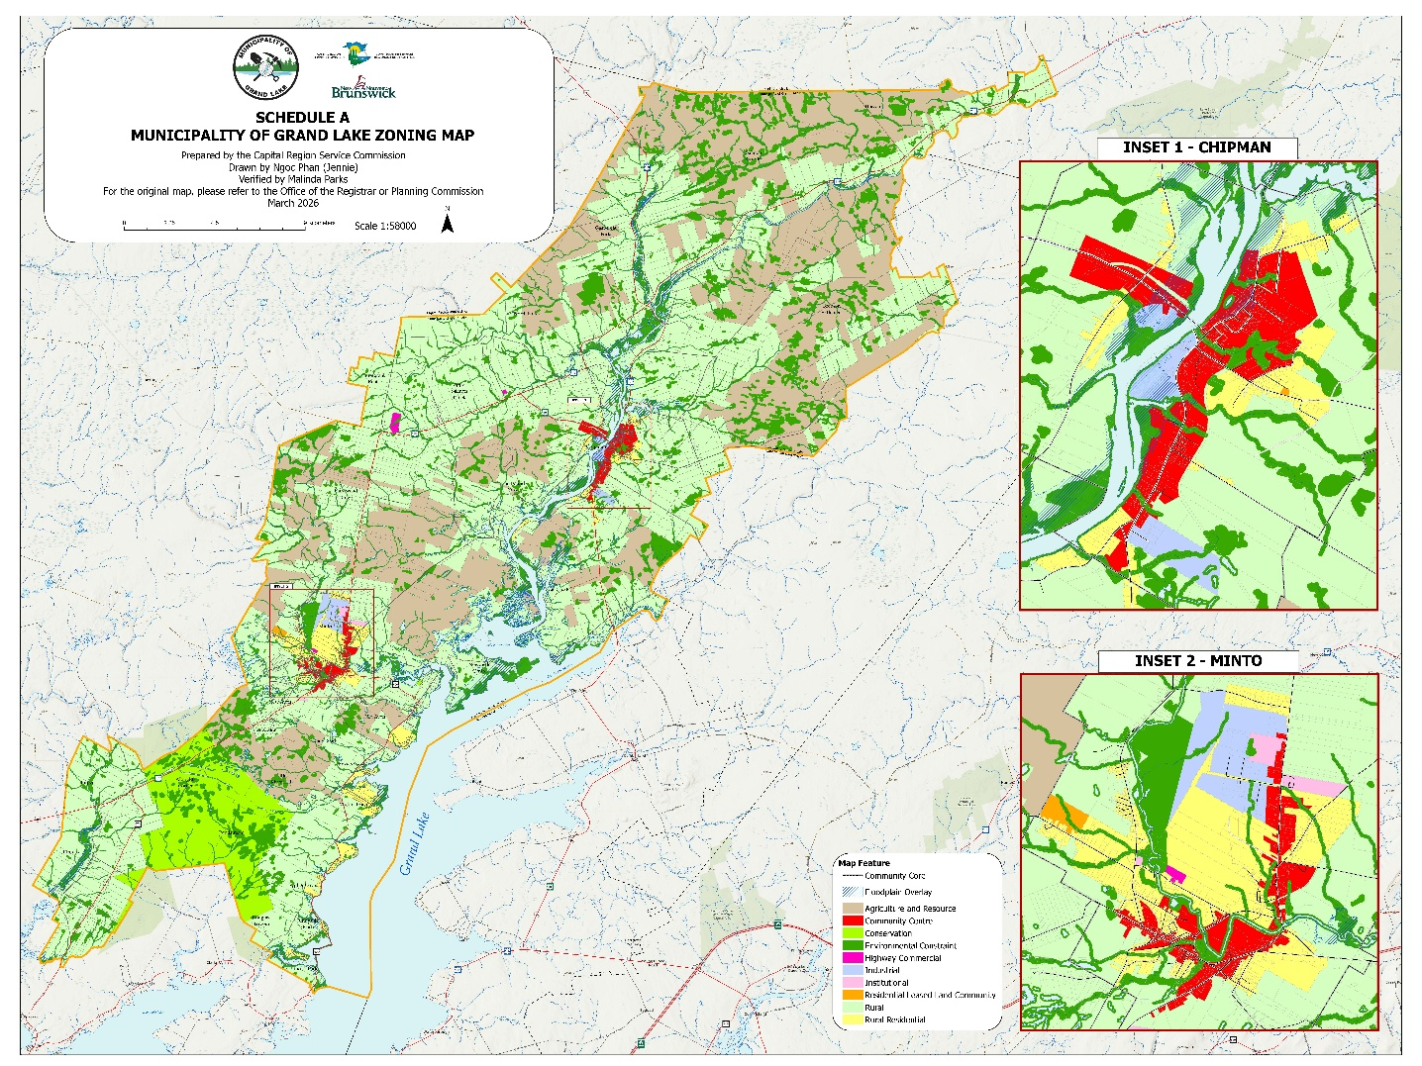

Municipality of Grand Lake

