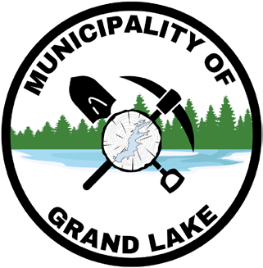
10 Civic Court, Unit 1 420 Pleasant Drive
Chipman, NB E4A 2H9 Minto, NB E4B 2T3
Tel: (506) 327-3383 Tel: (506) 327-3383
Fax: (506) 327-3041 Fax: (506) 327-3041

https://municipalityofgrandlake.ca

TENDER: Mobile Welding Services

Closing Date: May 19, 2026 at 1:00 p.m. (local time)
Submission Email: paul.dixon@municipalityofgrandlake.ca

1. Overview
The Municipality of Grand Lake is inviting tenders from qualified contractors to provide mobile welding services on an “as required” basis in support of municipal operations.

2. Scope of Work
The successful bidder will be required to:
a) Provide the services of a certified Journeyman Welder equipped with a fully outfitted mobile welding truck, including all necessary tools, torches, and related equipment;
b) Supply all labour, equipment, and expertise necessary to perform portable welding repairs and fabrication as required by the Municipality;
c) Respond to service requests on an “as and when required” basis to support Public Works maintenance activities.

3. Insurance Requirements
Bidders must carry and maintain Commercial General Liability insurance with a minimum coverage of $2,000,000 per occurrence. Proof of insurance must be provided upon request

4. Pricing Requirements
Bids must include:
- A comprehensive hourly rate for services, inclusive of all labour, equipment, tools, and operating costs (excluding materials);
- Confirmation of whether travel time and/or mileage to job sites is included in the hourly rate. If not included, travel costs must be clearly identified.

5. Submission Requirements
All submissions must be received by the closing date and time indicated above. Late submissions may not be considered.

6. General Conditions
The Municipality reserves the right to accept or reject any or all tenders and is not obligated to accept the lowest bid. The Municipality further reserves the right to award the contract in the best interest of the Municipality.

