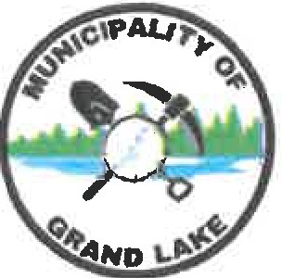
Municipality of Grand Lake
BY-LAW No. 02-02
A By-Law to Amend By-Law No. 02-01 -
A Code of Conduct By-Law for the Council
of the Municipality of Grand Lake

WHEREAS By-Law No. 02-01 entitled “A Code of Conduct By-Law for the Council of the Municipality of Grand Lake” was enacted on July 28, 2025;
AND WHEREAS Council wishes to make minor corrections and clarifications to the by-law and enhance certain provisions to comply fully with Regulation 2024-48 under the Local Governance Act;
NOW THEREFORE the Council of the Municipality of Grand Lake, duly assembled, enacts as follows:

1. Amendments
- Section 5(5) paragraph and subparagraph numbering is corrected:
  - Paragraph a contains subparagraphs (i) and (ii);
  - Paragraph b relates to disclosure of confidential information.

2. Improvements and Clarifications
- Independent Investigator / Consultant
- Council may appoint an independent investigator, consultant, or designate to conduct an impartial review of any complaint filed under this by-law. The investigator may request information, meet with parties, and submit a report and recommendations to council. The investigator’s findings are advisory; final decisions rest with council. (see 7(14)) If all of council is named in the complaint, upon receipt of the complaint, the clerk will forward the complaint to the Local Governance Commission for review. (see 7 (6))

- Confidentiality / Privacy
All complaints, proceedings, and records under this by-law shall be handled in accordance with the Right to Information and Protection of Privacy Act. Council members, staff, and investigators must maintain confidentiality, except as required by law or to implement corrective actions.
- Corrective Actions Limitations
Corrective actions imposed under this by-law shall be limited to those powers authorized under the Local Governance Act, including reprimand, apology, training, suspension of duties or remuneration, and temporary restriction of privileges. Council shall not exceed these powers in applying any corrective action.
- Open Session Requirement (per Local Governance Commission ruling)
  - All reviews and decisions by council under this by-law must occur in open session, except where the matter qualifies for closed session under Section 68(1) of the Local Governance Act. (see 8(1 & 3))
  - Initial review by the Mayor or Deputy Mayor may be done privately for procedural efficiency, but referral to council must comply with (a).
  - Any investigation report presented to council shall be in open session, unless confidentiality under Section 68 applies.

- Addition of the following:
3(8) Members of council must be fit to perform their duties and shall not attend Council or Committee meetings, or otherwise conduct municipal business, while impaired by alcohol, drugs, or any substance that affects their ability to participate in a competent, safe, and professional manner.

3(9) Where a member appears to be impaired, the Chair may require the member to leave the meeting, and such conduct may be subject to investigation and corrective action under this by-law.

