Chipman Station  10 Civic Court, Unit 1  Chipman, NB E4A 2H9  Phone 506-339-6601  Fax 506-339-6197 | 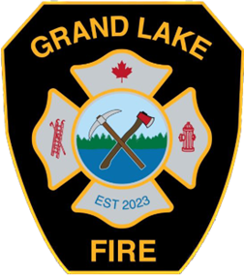 | Minto Station  187A Main Street  Minto, NB E4B 3N4  Phone: 506-327-3206
grandlake.firechief@municipalityofgrandlake.ca

Grand Lake Fire Department
Application for Membership

Name: Date of Birth:
Address:
SIN#: Present Occupation:
Employers Name:
Home Phone #: Work Phone #:
References #1: Phone #:
References #2: Phone #:
Please circle the answers to the following questions:
Which Station are you applying to work out of? Chipman / Minto
Can you be called away from work for Emergency Duties? Yes / No
Are you willing to take a Medical Examination? Yes / No
Are you willing to have a Criminal Record Check completed? Yes / No
Do you have spare time to involve yourself with Grand Lake Fire? Yes / No

Highest level of education completed:
What are your plans for the future:
List any experience you have had in the area of Firefighting, First Aid, CPR, or any other training or special courses you have received:

Briefly explain why you are interested in becoming a member of Grand Lake Fire:

Signature: Date:

